# Noise Pollution Monitoring

Presented by

R.Mariyappan,N.Sivaselvan,T.Rajaram,P.Ramar,M.Balasakthivel

ABSTRACT

This project focuses on the development and implementation of an IoT-based system for noise pollution monitoring. The escalating concerns regarding the adverse effects of noise pollution on both the environment and human well-being underscore the need for efficient and real-time monitoring solutions. Leveraging the capabilities of the Internet of Things (IoT), our system integrates smart sensors to collect noise data, which is then transmitted and processed through a centralized unit.

The connectivity and scalability of IoT provide a cost-effective and accessible framework for continuous noise monitoring. The report discusses the system architecture, sensor technologies, data transmission protocols, and the challenges encountered during the project's implementation.

The results highlight the system's effectiveness in providing real-time noise data, contributing to a comprehensive understanding of noise pollution patterns. This project serves as a step towards sustainable noise pollution management, with implications for urban planning and public health.

INTRODUCTION

Noise pollution, an often under estimated environmental challenge, has emerged as a pressing issue affecting the well-being of both ecosystems and human populations. As urbanization and industrialization continue to expand, so does the intensity and pervasiveness of noise, leading to detrimental effects on health, cognitive function, and overall quality of life.

Recognizing the imperative to address this concern, our project endeavors to develop a sophisticated and efficient solution for noise pollution monitoring, leveraging the transformative power of the Internet of Things (IoT).

By integrating smart sensor technologies with IoT connectivity, our system aims to provide real-time and comprehensive insights into noise levels, facilitating a proactive approach to noise pollution management. This introduction sets the stage for a detailed exploration of our IoT-based noise monitoring system, elucidating its architecture, functionalities, and potential implications for sustainable urban development and public health.

PROPOSAL SYSTEM:

Monitoring based diagnosis

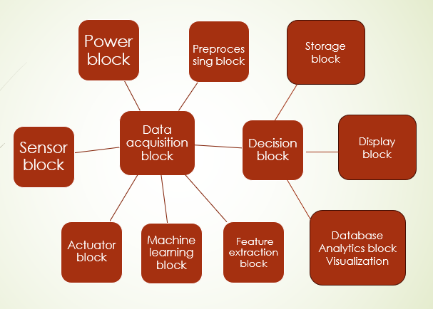

Analytics Block:

Analytics involve the in-depth analysis of data to derive meaningful insights. This block could generate reports, trends, or other valuable information.

Visualization Block:

Similar to the display block, the visualization block focuses on presenting data in a visually appealing and comprehensible manner.

Control Block:

This block is responsible for controlling the overall operation of the system. It could involve setting parameters, adjusting settings, or ensuring that the system operates within defined limits.

Diagnostic Block:

Diagnostics are essential for identifying and addressing issues within the system. This block monitors the system's health and provides feedback on its performance.

Safety Block:

Safety is paramount. This block ensures that the system operates in a safe manner, taking precautions to prevent accidents or malfunctions

Communication Block:

This block facilitates communication between different components of the system or with external systems. It could involve transmitting data, receiving commands, or sharing information.

Power Block:

This is where the system gets its energy. It ensures that all components have the necessary power to operate.

Storage Block:

Data storage is crucial for keeping records, historical data, or any information that needs to be preserved for future analysis.

Display Block:

The display block presents information in a human-readable format. It could involve visualizing data, showing system status, or providing feedback.

User Interface Block:

This block enables interaction with the system. It could include buttons, touchscreens, or other interfaces that allow users to input commands or receive information.

Database Block:

This block stores structured data for the system. It could include configuration settings, user profiles, or any data that needs to be accessed and retrieved.

Analytics Block:

Analytics involve the in-depth analysis of data to derive meaningful insights. This block could generate reports, trends, or other valuable information.

Visualization Block:

Similar to the display block, the visualization block focuses on presenting data in a visually appealing and comprehensible manner.

Control Block:

This block is responsible for controlling the overall operation of the system. It could involve setting parameters, adjusting settings, or ensuring that the system operates within defined limits.

Diagnostic Block:

Diagnostics are essential for identifying and addressing issues within the system. This block monitors the system's health and provides feedback on its performance.

Safety Block:

Safety is paramount. This block ensures that the system operates in a safe manner, taking precautions to prevent accidents or malfunctions.

This breakdown should give you a comprehensive understanding of each block's role in the system.

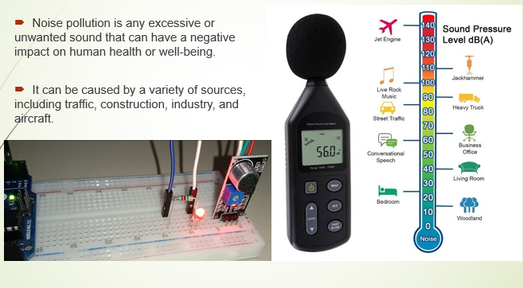**Components operation**

* **Piezo Noise Sensors**
* Explain the working principle of piezo noise sensors:
  + Conversion of mechanical vibrations (sound waves) into electrical signals.
  + High sensitivity to specific frequency ranges. 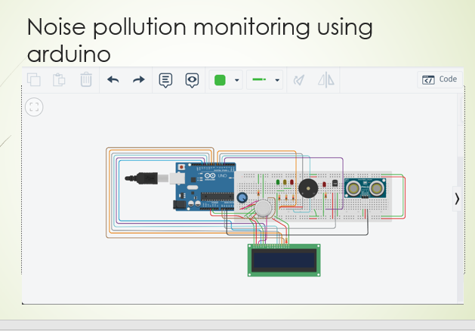
* **Ultrasonic Sensors**
* Describe the functionality of ultrasonic sensors:
  + Emitting ultrasonic waves and measuring their reflection.
  + Ideal for detecting high-frequency noise.

**Noise monitoring**

* + exposed to noise levels above 85db, it is important to wear earplugs and ermuffs to protect your hearing .
  + you should also take breaks from exposure to loud noises. If have any concerns about hearing

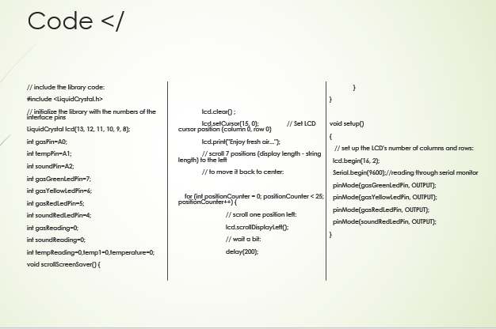

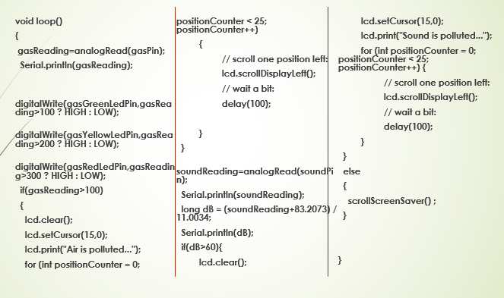

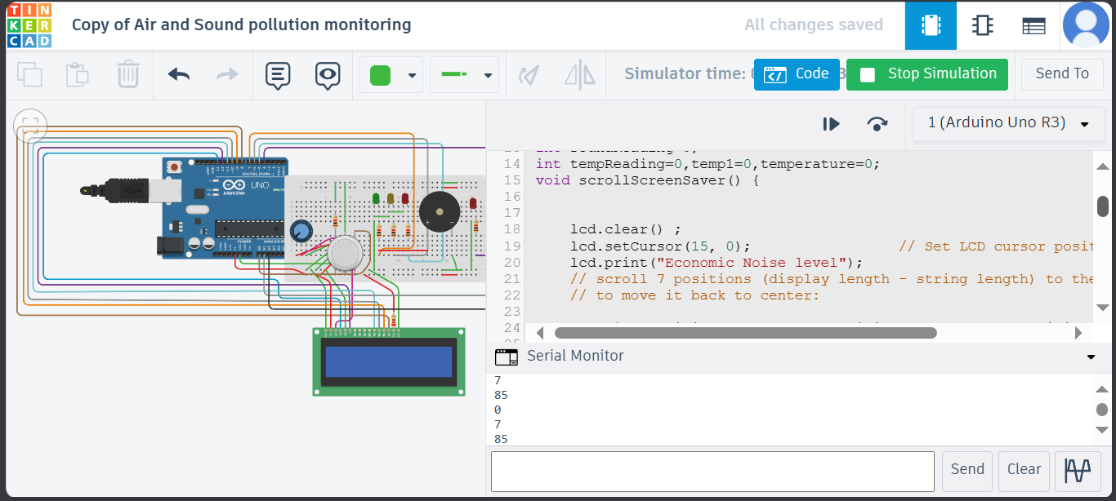

CODE:

import serial

import time

# Replace '/dev/ttyUSB0' with the actual serial port of your Arduino on the Raspberry Pi

ser = serial.Serial('/dev/ttyUSB0', 9600, timeout=1)

while True:

try:

# Read data from the serial port

data = ser.readline().decode('utf-8').strip()

# Print the received data

print("Received Data: ", data)

# Add your code here to process the data as needed

# Wait for a moment before reading the next data

time.sleep(1)

except KeyboardInterrupt:

print("Exiting...")

break

# Close the serial port when done

ser.close()

Benefits:

Simple setup for quick noise monitoring.

Great for various applications, from home use to workplace safety.

Testing:

For testing used simulator,

* TINKERCAD

Before using it in the real world, we can test our setup in a virtual environment using Arduino simulation.

Future Ideas:

This basic prototype can be a starting point for more advanced features, like recognizing different types of sounds or integrating with smart home systems.

Conclusion:

Creating a noise monitoring system doesn't have to be complicated. With Arduino and a noise sensor, you can build a simple yet effective prototype to keep tabs on your acoustic surroundings.